Chapter 3, Problem 19.

Use nodal analysis to find v₁, v₂, and v₃ in the circuit in Fig. 3.68.

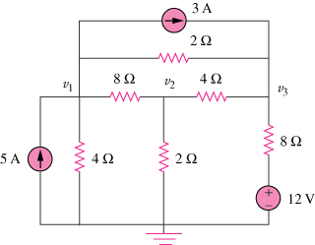

Figure 3.68
For Prob. 3.19.

